DAI CUONGPrimary School  Class: 4 ……  Name: …………………………………… |  |  |  | THE FINAL SEMESTER TEST  ENGLISH - CLASS 4  Time: 35 minutes
 | Skill | Listening | Reading |  | Writing | Speaking | Total
 | Mark

LISTENING
PART 1: Questions 1-4: Listen and match. There is one example. (1pt)
A

Example: You hear: 0. What time is it?-> It’s seven o’clock. The answer is:
 | A   | B   | C  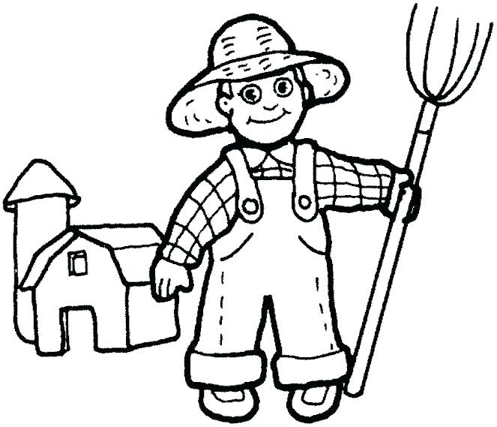 | D   | E  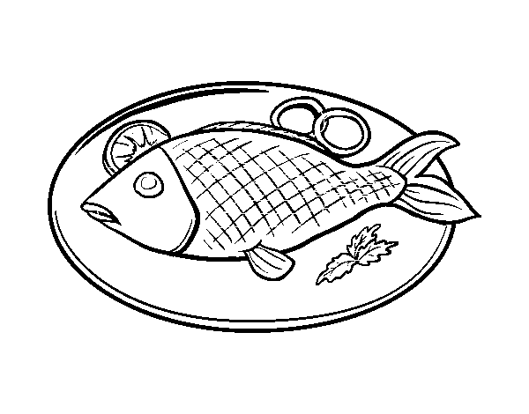
0
1
2
3
4

PART 2: Questions 5-8: Listen and number from 1to 4. There is one example. (1pt)
A

Example:You hear: 0. Would you like some bread? –Yes, please.->The answer is:
 | A  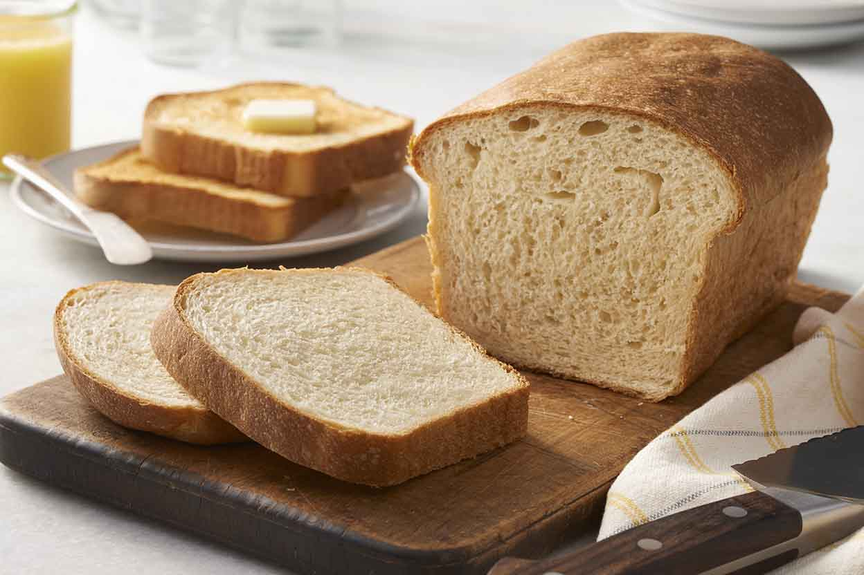 | B  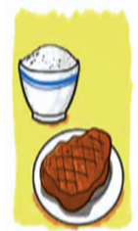 | C   | D   | E  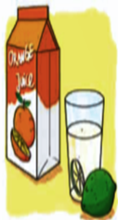
0

PART 3: Questions 9-12: Listen and tick the box. There is one example.(1pt)
Example :(0).What does your father do? -> He’s a taxi driver. The answer is: A
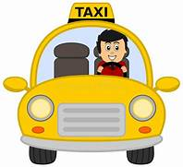

  A.
  B.
  C.
9.
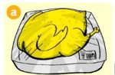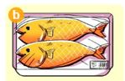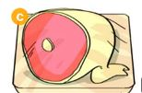
   10.

11.
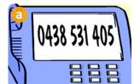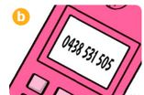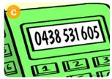
12
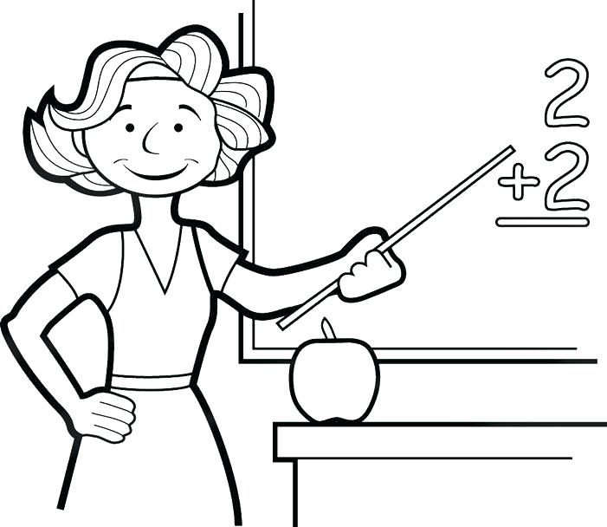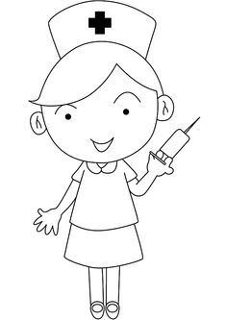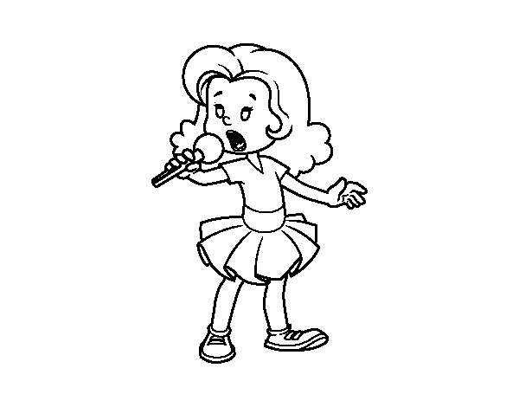

READING
PART 1:Questions 1-4. Read and circle the correct answers.There is one example (0).( 1pt)
It’s 7 o’clock now. Lan often gets up at 6 o’clock but today she gets up late because she doesn’t go to school. This morning, she goes to the Tet market with her mother, she often buys new clothes and flowers. She decorates her house in the afternoon. During Tet she often eats a lot of Banh Chung and gets lucky money from her parents.There is a lot of fun at Tet holiday.
Example (0). What time does Lan often get up?
B
A. five o’clock B. six o’clock C. six thirty
1. This morning, she goes to the ______________ market with her mother.
- Christmas B. Tet C.New Year
2. She often buys new______________ and flowers.
- clothes B. clothe C. blouse
3.She decorates her ____________ in the afternoon.
- school B. home C. house
4. At Tet, she gets _____________from her parents.
- lucky money B. card C. flowers
PART 2. Questions 5-7. Match the words with pictures. There is an example. (0.75pts)
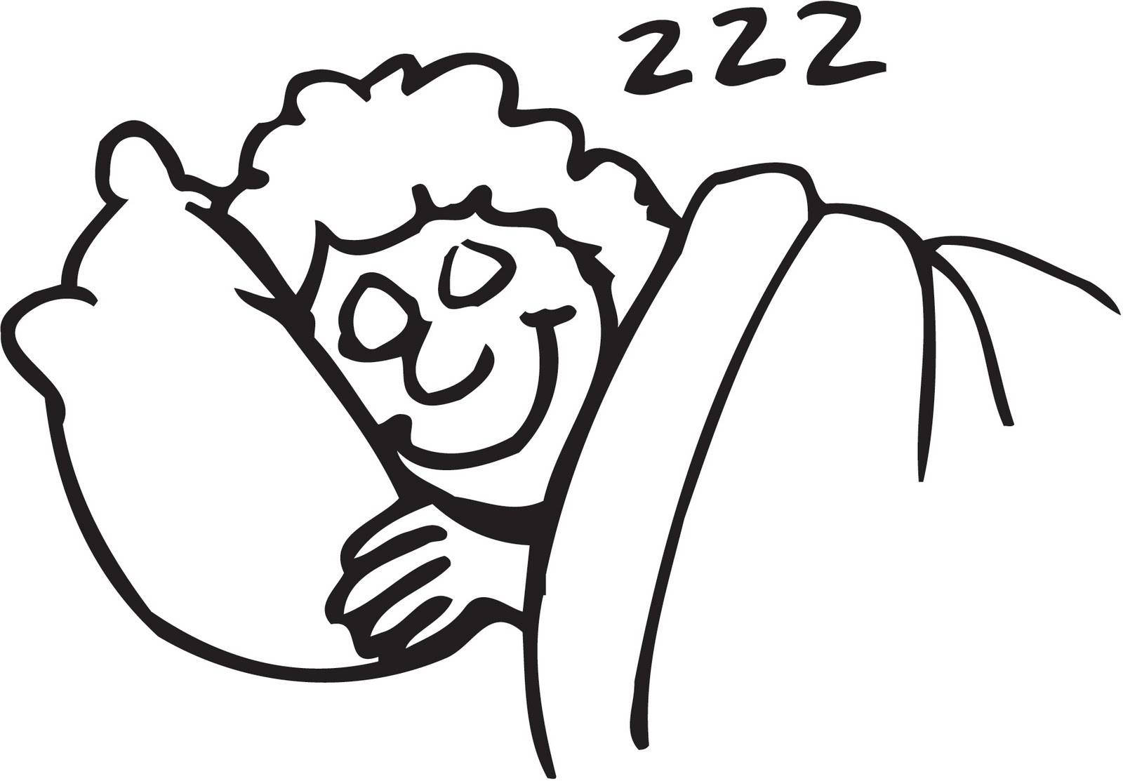 |  | 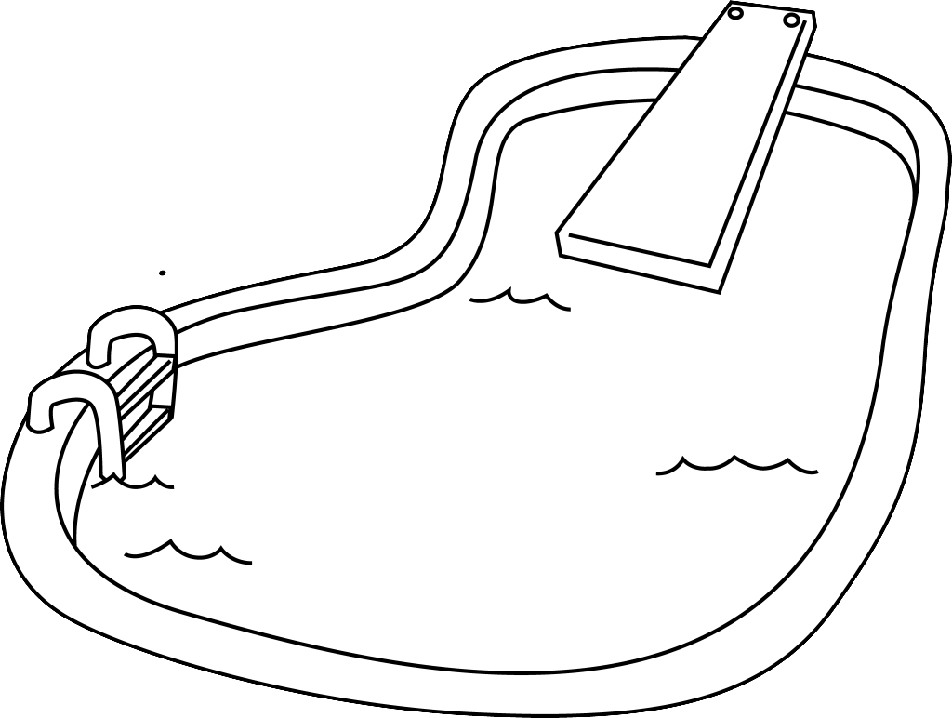 | 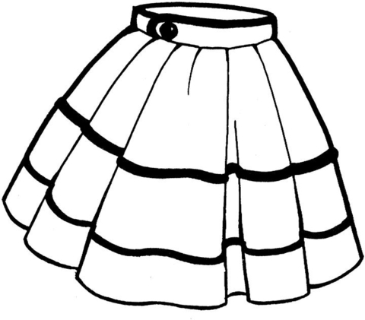
A | B | C | D
(0) Example: a doctor | 5. go to bed | 6. a skirt | 7.swimming pool
PART 3. Questions 8 -10.Read and fill the gaps with the correct words. There is an example (0.75pts)
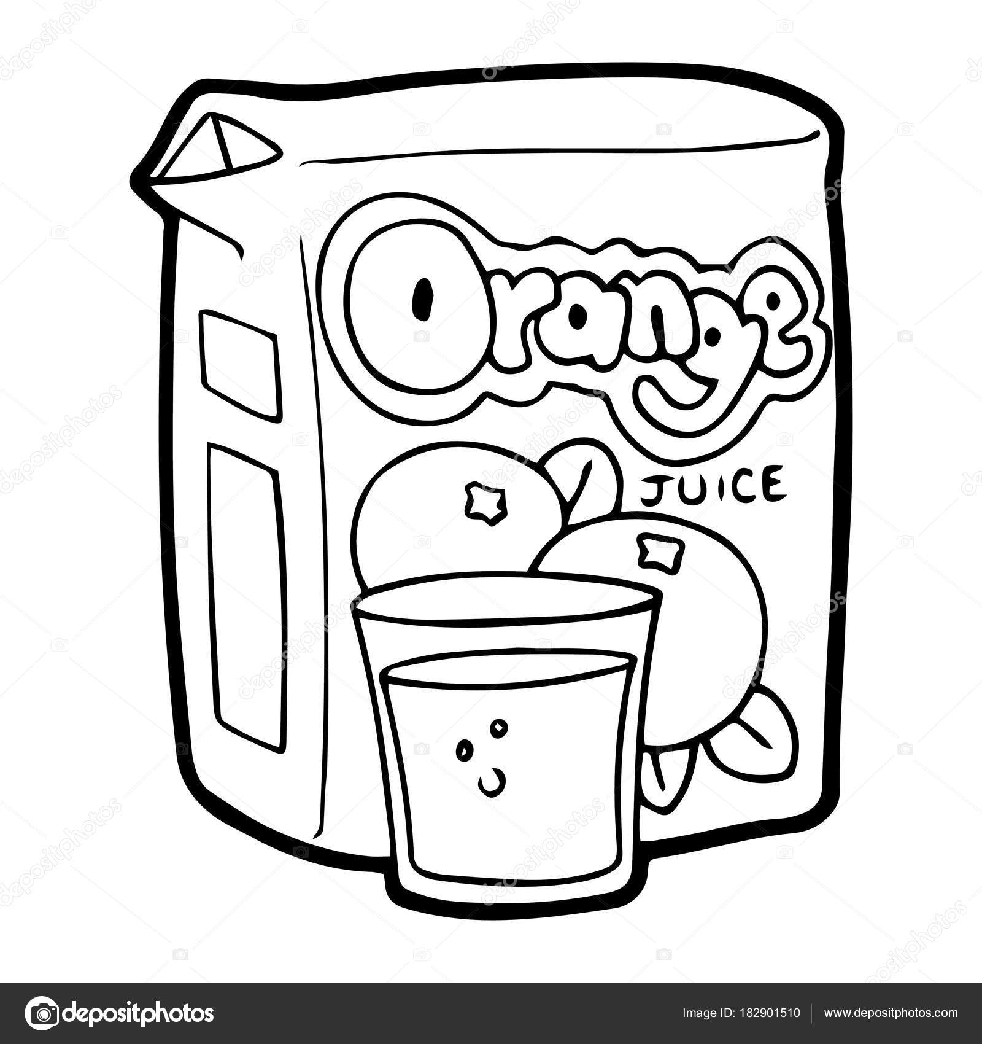 | 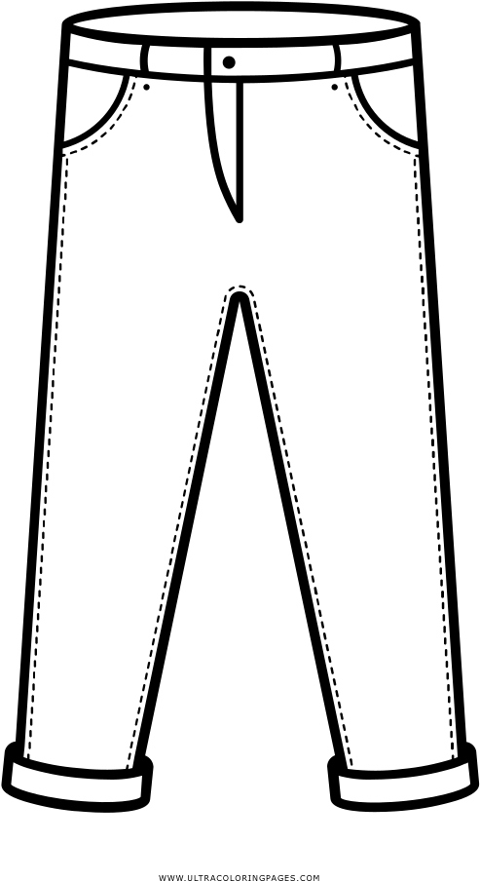 | 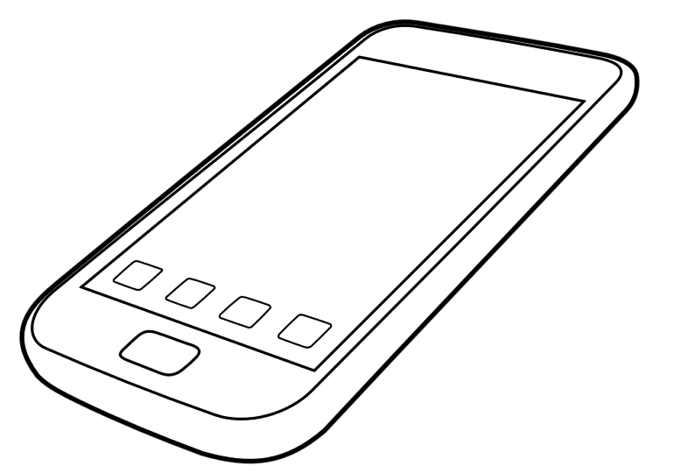 | 
orange juice | jeans | mobile phone | student
Hello! This is the report of my interview with a classmate. His name is Tony, He is a (0) student at Oxford Primary School. He likes taking photographs with his (8) ………………………………… He wants to go to the zoo to see the animals. His favourite food is chicken. His father is a driver. He is young and tall. He likes wearing (9) ……………………..and T- shirt. His mother is a teacher. She is young and slim. She likes reading books and drinking(10)……………………………. …….…She often goes to the bookshop and the supermarket at weekends.
WRITING
PART 1: Questions 1- 3: Look at the pictures and the letters. Write the words. There is an example. (0.75pts)
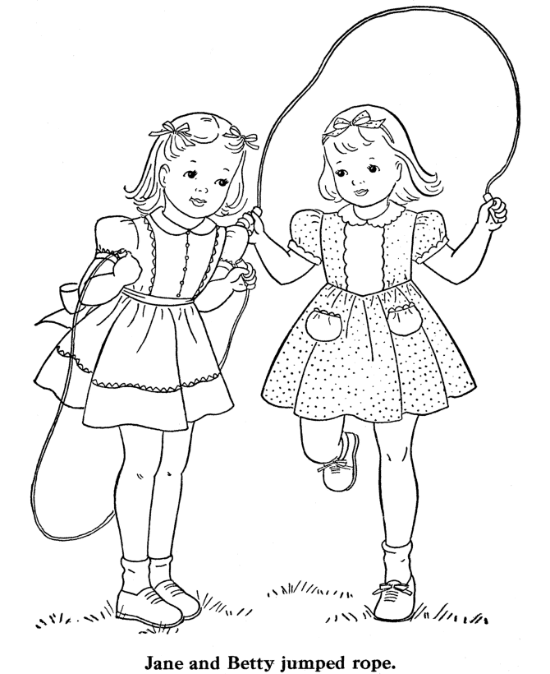 |  | 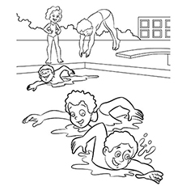
kipsping-> skipping | 1. soesh  - >_____________ | 2.mingwism  -> ________________ | 3. merfar  -> _________________
PART 2 :Questions 4 – 7. Reorder the words to make the sentences. There is an example. (1pt) Example (0). is / Monday / today/./ -> Today is Monday.
4.number/ your/ What’s/ phone/?/
___________________________________________
5. is/ The jacket/ dong/ fifty thousand /./
____________________________________________
6. get up/ What time/ you/ do/?
____________________________________________
7.family members/ firework/ are/ watching/ displays/My/ together/./

_____________________________________________

PART 3:Questions 8 – 10. Write the correct words for each gap. There is one example.(0,75pts)
beef and lemonade | goes to school | Christmas | a factory

Tom is from America, every day he (0 ) goes to school at 7:10. His father is a worker, he works in (8) …………………………………… Tony does not like chicken and fish. His favourite food and drink are (9) ………………………………............... At (10) …………………. .…..he’s going to get presents and see Santa Claus. It is the festival he likes best.

SPEAKING: (2pts)
Part 1
Part 2
Part 3
The end.

ĐÁP ÁN VÀ BIỂU ĐIỂM BÀI KIỂM TRA ĐỊNH KỲ CUỐI NĂM HỌC
MÔN TIẾNG ANH LỚP 4 – NĂM HỌC 2021-2022

LISTENING
PART 1: Questions 1-4: Listen and match. There is one example. (0,25*4 =1pt)
1C 2B 3E 4D
PART 2: Question 5-8. Listen and number(0,25*4 =1pt)
1 C 2D 3B 4E

PART 3 :Question 9-12. Listen and tick the box(0,25*4 =1pt)
1B 2B 3C 4A
READING:
PART 1 (0,25*4 =1pt)
1.B 2. A 3. C 4.A
PART 2(0,25*3 =0.75 pts )
5. A 6. D 7. C
PART 3(0,25*3 =0.75 pts )
8. mobile phone 9. Jeans 10. orange juice
WRITING:
PART 1(0,25*3 =0.75 pts ) 1. shoes 2.swimming 3.farmer
PART 2(0,25*4 =1pt)
4. What’s your phone number?
5. The jacket is fifty thousand dong.
6. What time do you get up?
7. My family members are watching firework displays together.
PART 3 (0,25*3 =0.75 pts )
8. a factory 9. beef and lemonade 10. Christmas.
SPEAKING:

Greeting & test taker’s name check.
The examiner says “My name is…It’s nice to talk to you today.”
Part 1: Getting to know each other: (0,5 pts)
- What’s your name?
- What class are you in?
- What time is it now?
Part 2: Talking about your family member and their jobs: (0,5pts)
- What does your father/ mother/ sister/ brother look like?
- What does your father/ mother/ sister/ brother do?
- Where does he/ she work?
- What’s his/ her phone number?
Part 3: Talking about familiar topic: (1pt)
a/Talking about Tet holiday
+ When is Tet?
+ What do you do on Tet?
+ Do you like Tet?
b/ Talking the prices and food, drink and reason to go somewhere
+ What is your favourite food/ drink?
+ How much is your skirt/ T-shirt/ shoes/ scarf..?
+ Why do you want to go to the cinema/ park/ bookshop..?

