|  |  |  |  |  |  |  |  |
| --- | --- | --- | --- | --- | --- | --- | --- |
| **DAI CUONG Primary School**  **Class**: **4** ……  **Name:** …………………………………… | | | | **THE FINAL SEMESTER TEST**  **ENGLISH - CLASS 4**  **Time: 35 minutes** | | | |
| **Skill** | **Listening** | **Reading** | | **Writing** | **Speaking** | **Total** | |
| **Mark** |  |  | |  |  |  | |

**LISTENING**

**Question 1: Listen and number from 1to 4. There is one example. (1pt)**

**Example:** You hear: **(**0).What’s he doing?->He is playing football.*The answer is: A*

|  |  |  |  |  |  |
| --- | --- | --- | --- | --- | --- |
|  | **A**  **play football** | **B**  CT1-TATH-De%20thi%20hoc%20ki%202-lop%204-anh%2063 | **C**  CT1-TATH-De%20thi%20hoc%20ki%202-lop%204-anh%2058 | **D**  CT1-TATH-De%20thi%20hoc%20ki%202-lop%204-anh%2060 | **E**  CT1-TATH-De%20thi%20hoc%20ki%202-lop%204-anh%2064 |
| **0** | | | | | |

**Questions 2: Listen and tick A, B or C .There is one example.(1pt)**

**Example** :(0).What animal do you want to see? -> I want to see zebras. *The answer is: A*

 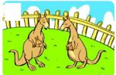 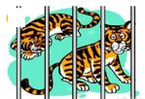

|  |  |  |  |  |  |  |  |  |  |
| --- | --- | --- | --- | --- | --- | --- | --- | --- | --- |
| |  |  | | --- | --- | | A*.* |  | | |  |  |  | | --- | --- | --- | | B*.* |  |  | | |  |  | | --- | --- | | C*.* |  | |

1.

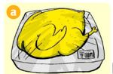 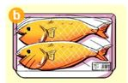 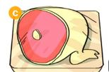

   2.

  

  

3.

  

  

4

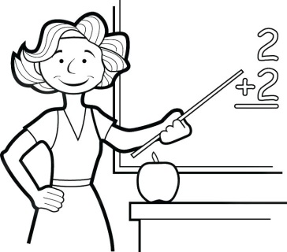 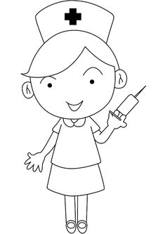 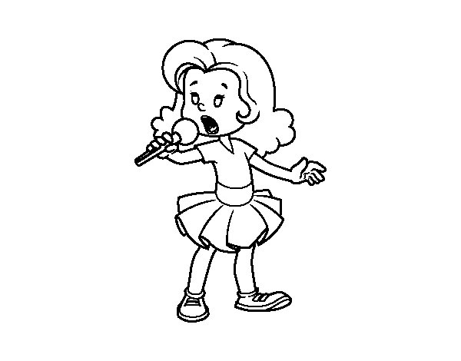

  

**Question 3: Listen and match. There is one example. (1pt)**

**A**

**Example:** You hear:0.What time is it?-> It’s seven o’clock.*The answer is:*

|  |  |  |  |  |  |
| --- | --- | --- | --- | --- | --- |
|  | **A**  CT1-TATH-De%20thi%20hoc%20ki%201-lop%204-anh%20170 | **B**  CT1-TATH-De%20thi%20hoc%20ki%201-lop%204-anh%20182 | **C**  Káº¿t quáº£ hÃ¬nh áº£nh cho farmer for coloring | **D** | E |
| **1**  **4**  **3**  **2**  **0** | | | | | |

**READING AND WRITING**

**Question 1. Read and complete with the correct words. There is an example (0) (1pt)**

|  |  |  |  |  |
| --- | --- | --- | --- | --- |
| beef | America | festival | factory | because |

Tom is from (0)**America** every day he goes to school at 7:10. His father is a worker, he works in a (1) …………………………………… Tony does not like chicken and fish. His favourite food is (2) ………………………………............... He loves monkeys (3) …………….. they are so funny, but he does not like elephants because they are big. At Christmas he’s going to get presents and see Santa Claus. It is the (4)  …………………. .….. he likes best.

**Questions** **2. Read and match the words with the pictures. There is an example. (0)** **(1pt)**

|  |  |  |  |  |
| --- | --- | --- | --- | --- |
| **A** | **B** | **C** | **D** | **F** |
|  | | | | |
| (0).tiger | 1. shoes | 2. sandcastle | 3. seafood | 4. go to bed |

**Question 3. Read and circle the correct answers.There is one example (0).( 1pt)**

Hello! This is the report of my interview with a classmate. His name is Tony. He is a student at Oxford Primary School. He likes taking photographs with his mobile phone. He wants to go to the zoo to see the animals. His favourite food is chicken. His father is a driver. He is young and tall. He likes wearing Jeans and T-shirt. His mother is a teacher. She is young and slim, She likes reading books and drinking orange juice. She often goes to the bookshop and the supermarket at weekends.

**Example** (0) . His name is……….?

A. John B. Tony C. Peter

1. He is a_____________________ at Oxford Primary School.

1. student B. teacher C.doctor

2. He wants to go to the__________________to see the animals.

A. cinema B. zoo C. school

3.He likes wearing ____________ and T-shirt.

1. trousers B. shoes C. Jeans

4. His mother likes _____________books and drinking orange juice.

1. reading B. buying C. seeing

**Question** **4. Look and write the correct word for each picture. There is an example (0)** **(1pt)**

|  |  |  |  |  |
| --- | --- | --- | --- | --- |
| mother | elephant | chicken | skipping | worker |

|  |  |  |  |  |
| --- | --- | --- | --- | --- |
| CT1-TATH-De%20thi%20hoc%20ki%202-lop%204-anh%20206 | CT1-TATH-Lop%204-DTHK%202-D19-anh%2010(1) | CT1-TATH-Lop%204-DTHK%202-D19-anh%201 | construction-worker-clipart-15 | CT1-TATH-De%20thi%20hoc%20ki%202-lop%204-anh%207 |
| (0)chicken | 1.____________ | 2.______________ | 3.____________ | 4.____________ |

**Question 5 .Look at the pictures and choose the correct answer. There is an example. (0) (1pt)**

|  |  |  |  |  |
| --- | --- | --- | --- | --- |
| CT1-TATH-De%20thi%20hoc%20ki%202-lop%204-anh%201 |  |  |  |  |
| (0) a. water  b. milk | (1) a. New Year  b. Christmas | (2) a. skating  b. skipping | (3) a. bakery  b. pharmacy | (4) a. crocodile  b. kangaroo |

**SPEAKING: (2pts)**

**Part 1**

**Part 2**

**Part 3**

**Part 4**

**ĐÁP ÁN VÀ BIỂU ĐIỂM BÀI KIỂM TRA ĐỊNH KỲ CUỐI NĂM HỌC**

**MÔN TIẾNG ANH LỚP 4 – NĂM HỌC 2021-2022**

**LISTENING:**

**Question 1.(0,25*4 =1pt)**

1.C 2.D 3.B 4.E

**Question 2.(0,25*4 =1pt)**

1.B 2.B 3.C 4.A

**Question 3. (0,25*4 =1pts)**

1.C 2.B 3.E 4.D

**READING AND WRITING:**

**Question 1. Read and complete with the correct words. (0,25*4 =1pt)**

1.factory 2. beef 3. because 4. festival

**Questions** **2. Read and match the words with the pictures. (0,25*4 =1pt)**

1.C 2. A 3. F 4. D

**Question 3. Read and circle the correct answers. (0,25*4 =1pt)**

1.C 2. B 3. CF 4. A

**Question** **4. Look and write the correct word for each picture. (0,25*4 =1pt)**

1.skipping 2. elephant 3. worker 4. mother

**Question 5 .Look at the pictures and choose the correct answer. (0,25*4 =1pt)**

1.B 2. A 3. B 4. A

**SPEAKING: 2 pts**

**Greeting & test taker’s name check.**

The examiner says “*My name is…It’s nice to talk to you today.”*

**Part 1: Getting to know each other: (0,5 pts)**

1. What’s your name?
2. What class are you in?
3. What time is it now?

**Part 2: Look and say(0,5 pts)**

* T shows some pictures(flashcard or pictures in textbook). SS look and say the words.

**Part 3: Point, ask and answer(0,5 pts)**

* T shows some pictures. (flashcard or pictures in textbook). SS point ask and answer.

**Part 4: Talk. (0,5 pts)**

**(SS choose topic to talk)**

a/Talking about Tet holiday

+ When is Tet?

+ What do you do on Tet?

+ Do you like Tet?

b/ Talking the prices and food, drink and reason to go somewhere

+ What is your favourite food/ drink?

+ How much is your skirt/ T-shirt/ shoes/ scarf..?

+ Why do you want to go to the cinema/ park/ bookshop..?

c/Talking about family.

+ What does your father/ mother/ sister/ brother look like?

+ What does your father/ mother/ sister/ brother do?

+ Where does he/ she work?

+ What’s his/ her phone number?