DAI LOC DEPARTMENT OF EDUCATION & TRAINING  DAI CUONG PRIMARY SCHOOL  Full name: …….……………………………  Class: 5………………… | THE SECOND SEMESTER TEST  Subject: English – Grade: 5  Time: 20 minutes  School year: 2023-2024

Marks: | Comment(s) | Listening | Reading | Writing | Speaking

PART I. LISTENING (20 minutes). (5pts).

Question 1: Listen and match the numbers with the correct pictures. There is an example(1,5pts).
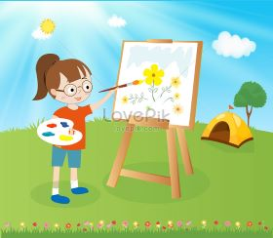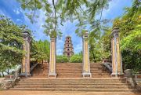
A B C D E F G

0
1
2
3
4
5
6

Question 2: Listen to the questions and tick the correct answers. There is an example.(1pt)
0. It’s cold and rainy. It’s opposite the library. It’s on the table.
A B C

1. He has two bananas. He has a fever. He has one brother.
A B C
2. I eat two bars. I have four bottles. I eat four bowls.
A B C

3. I’d like to buy something. I’d like to visit the museum. I’d like to be a dentist.
A B C

4. It will be cold and windy. There are a lot of flowers. It’s usually cold and rainy.
A B C

Question 3: Listen to the dialogue(s) and tick () the correct pictures. There is an example.(1,25pt)
0.
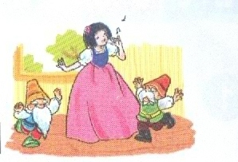
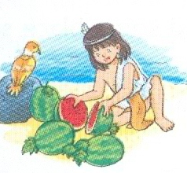
A. 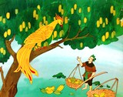 B. C.
1.
A.  B.  C. 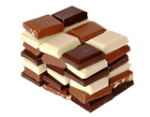

2.
A.  B.  C. 

3.
A.  B. 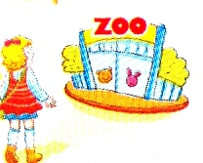 C. 

4.
A. 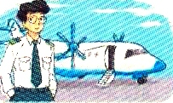 B. 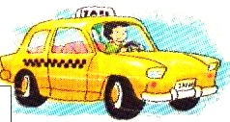 C. 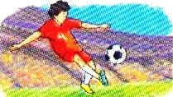

5.
A. 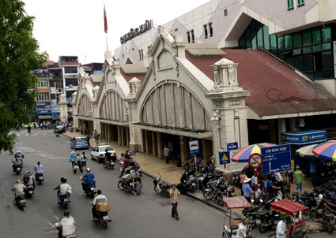 B. 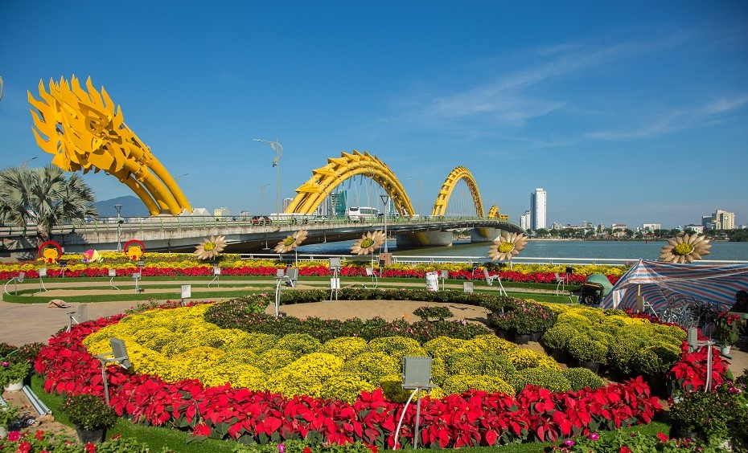 C. 

Question 4: Listen and complete. There is an example. (1,25pts)

1. I have a headache.

2. Mai shouldn’t play with the .................... because she may get a burn.

3. Akiko’s mother goes..........................in her free time.

4. I think the main character is................................

5. I’d like a carton of.............................................., please.
6. The .............................. is opposite the pharmacy.

DAI LOC DEPARTMENT OF EDUCATION & TRAINING  DAI CUONG PRIMARY SCHOOL  Full name: …….……………………………  Class: 5………………… | THE SECOND SEMESTER TEST  Subject: English – Grade: 5  Time: 40 minutes  School year: 2023-2024

PART II: READING (20 minutes). (5pts).
Question1 : Look and read. Write the correct words. There is an example.(1,25pts)
 |  |  |  |  | 
A. architect | B. orange juice | C. stadium | D. pharmacy | E. peacock | F. teacher

- This bird has long and colourful tails peacock
1. | She loves children and she helps them to learn. | __________________
2. | He is a person who designs buildings. | __________________
3. | We buy medicine at this place. | ___________________
4. | The place you can watch football matches. | __________________
5. | This drink is very good for your health. | __________________
Question 2: Read and tick (T) True or F (False) in the gaps. There is an example. (1,25pts)
My name is Hoa. I live in Ha Noi. It is in the north of Viet Nam. I love the weather in here. There are four seasons in the north: spring, summer, autumn and winter. In spring, it’s warm and you can see many flowers. In autumn, there are a lot of fish in the lakes, rivers and people often go fishing. Winter is cold and people like staying at home or going to the cinema. I like summer the most because I don’t go to school and I can go swimming nearly every morning and afternoon.

True False


0 Hoa lives in the south of Viet Nam.

1. Hoa loves the weather in Ha Noi.

2. There are a lot of flowers in spring.

3. People often go fishing in the lakes and rivers in summer.

4. In winter, people like seeing films.

5. Hoa can go swimming at weekends in summer.
Question 3: Read and reorder the sentences to make a complete dialogue. It begins with 0.(1,25pts)

 | A | Mai: Why would you like to have that job?
 | B | Nam: I’d like to be a teacher
 | C | Nam: Because I’d like to teach young children.
0 | D | Mai: What would you like to be in the future, Nam?
 | E | Nam: In a school in the mountains.
 | F | Mai: Where would you like to work?

Question 4: Read and choose the best answers. There is an example.(1,25pts)
Hi. My name is Hoa. I like reading books, especial folk tales. Folk tales are usually short and interesting. The characters are sometimes honest, sometimes greedy. I like The Golden Star Fruit Tree very much. The younger brother was honest, but the older brother was not. At the end of the story, the older drowned in the sea because he was so greedy. The younger could live in a luxury life from then on. I love folk tales very much because they give me the lesson in life.

- What kind of story does Hoa reading?
B.
A. short story B. folk tales C. funny story
1.How are the folk tales?
A. short B. interesting C. short and interesting
2. What story does she like?
A. The Fox and the Crow B. The Golden Star Fruit Tree
C. Aladdin and magic lamp
3. What’s the older brother like?
A. honest B. generous C. greedy
4. What happened finally in that story?
A. The older drowned in the sea. B. She likes the story. C. The younger was honest.
5. Why does she like folk tales?
A. Because they help her to learn lessons at school.
B. Because she can get the lesson in life.
C. Because they give her life.

PART III: WRITING (20 minutes). (5 pts)

Question 1: Read and complete. There is an example. (1,25pts)

Hi. My name is Mai. In my free time, I often go  (0) skating with my

classmates because I like sports very much. My father likes sports, too. He does 

(1) twice a week. My mother likes 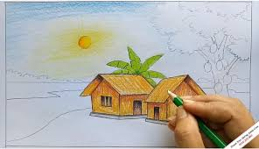 (2)

pictures because she is an artist. My sister loves  (3)

, so she wants to be a  (4) . My brother likes reading science books because he would like to be a scientist. My family often has dinner and
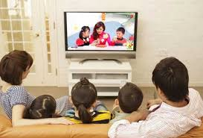 (5) TV together every Sunday evenings.

Question 2: Complete the sentences with the given words. There is an example. (1,25pts)
Example: 0. The/ stadium / next / to / the/ swimming/ pool/.
→ The stadium is next to the swimming pool.
1. What / do / you / do / your / free/ time?
→ ............................................................................................
2. What/ would/ you/ to/ be/ the/future/?
→ ............................................................................................
3. It/ will/ hot/and/ sunny/ Ha Noi/ tomorrow.
→ ............................................................................................
4. I’d/ a/ sandwich, /please. /
→ ............................................................................................
5. How / water / do / you / drink / every / day? /
→ ............................................................................................
Question 3. Write a letter to tell your friend about the weather in your country. Using guiding questions(2,5pts)
(about 35-45 words).

- How many seasons are there in your country?
- What are they?
- What is the winter like?
- What is your favourite season?
- What is the weather like in your favourite season?

Dear…………………,
………………………………………………………………………………………………………………………………………………………………………………………………………………………………………………………………………………………………………………………………………………………………………………………………………………………………………………………………………………………………………………………………………………………………………………………………………………………………………………………………………………………………….……………………………………………………………………………………………
………………………………………………………………………………………………………………………………………………………………………………………………

PART IV. SPEAKING. (11minutes). (5 pts)

- Get to know each other:
To do/ To say | Response | Back-up
1/ Teacher (T) ask 5 questions about personal information:  T asks 2 questions:  + What’s your name?  + How do you spell your name?  (or How old are you?.)  T asks 3 questions:  + What day is it today?/ What is the date today?  + What is your favourite subjects/ foods/drink/ animals/books/ stories/…?  + How many pets do you have?/ What are they? What pet do you like?  + How many people are there in your family?  + What do you do in your free time?  + What would you like to be in the future?  + Which place would you like to visit? | My name’s Hoa.  H-O-A.  I’m eleven years old.  It’s Monday/....It’s the fifth of May/…  My favourite subject is English /...  It’s chicken/orange juice/monkeys/......  I have two/ three....They are dogs/cats/....I like cats...  There are three/ four /five... people in my family.  I read comic books ....  I often listen to music…..  I’d like to be a doctor….  I’d like to visit…….. | Do you do morning exercise?/play badminton, play football/ do homework, watch TV.

2. Respond the questions:
- Teacher point to an object and say a sentence about this object. The pupil will respond.

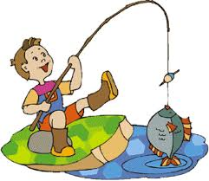 | 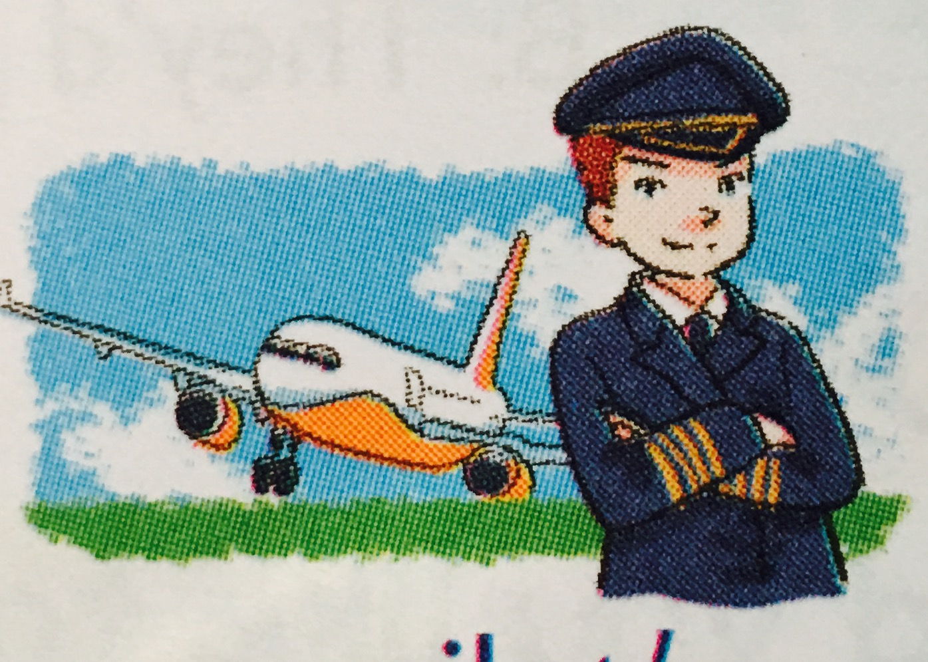 | 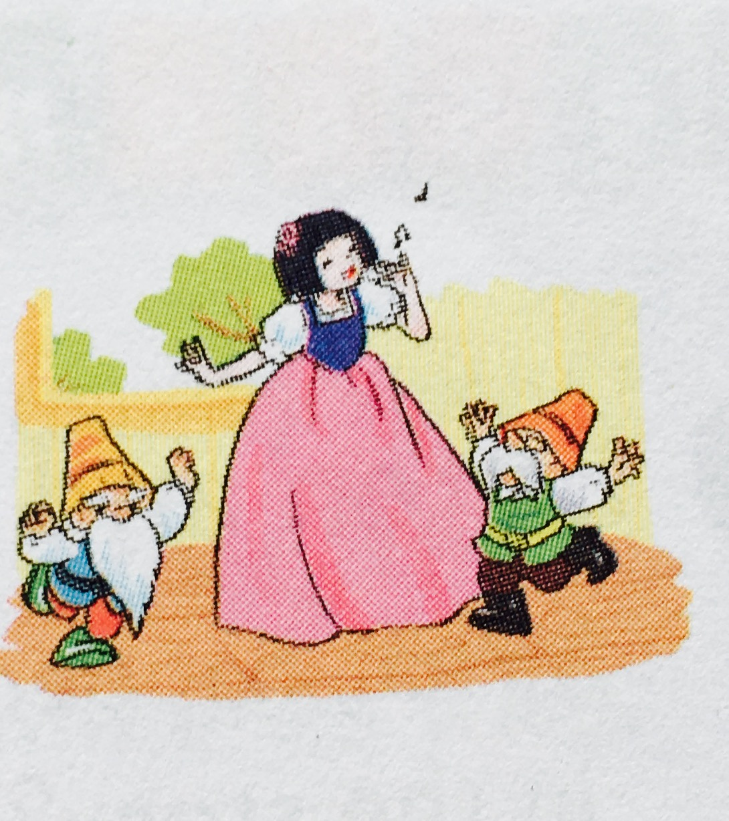 | 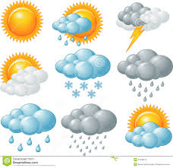
card 1 | card 2 | card 3 | card 4

To do/ To say | Response | Back-up
-Teacher (T) shows card 1 (rainy)  T says: Now, look at this card.  -Teacher (T) shows card 2  (Picture about a pilot)  -Teacher (T) shows card 3  (Picture about Snow White)  -Teacher (T) shows card  (Picture about weather) | I often …….  Yes, I do/ No, I don’t.  I’d like to be……  Because I’d like …….  Yes/No  I think she’s…….  It’s………………….  I like………………..  Because……………… | What do you do in your free time?  Do you like going fishing?  What would you like to be in the future?  Why would you like to be ….?  Do you like fairy tales?  What do you think of Snow White?  What’s the weather like today?  Which season do you like? Why?

3. Describe the picture:
- Ask pupils to look at the pictures and describe the pictures. For example:
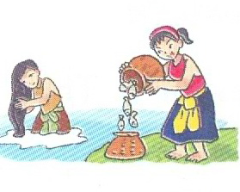 | 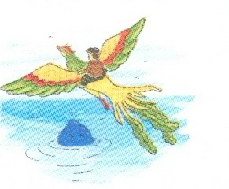 | 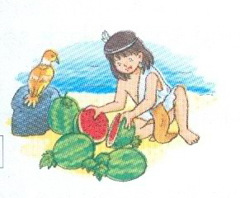 | 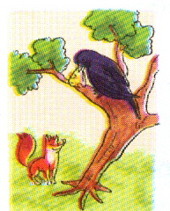
card 1 | card 2 | card 3 | card 4

- What is the name of the story?
- What can you see in the picture?
- What is the main character of the story?
- How is the character?
- Do you like the main character? Why?

